**Practical for linux-command workshop**

1)For seeing calendar

Command: cal month year

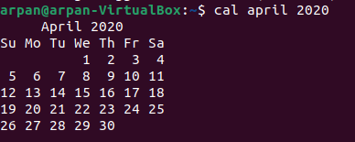

2)For seeing date

Command: date



For specifically seeing date with hour, minute or second.



3)For printing the message

Command: echo “text” or we can use printf “text %d\n” number.





4)For text based calculator

Command: bc

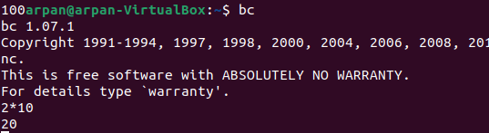

5)For graphical calculator:

Command: xcalc

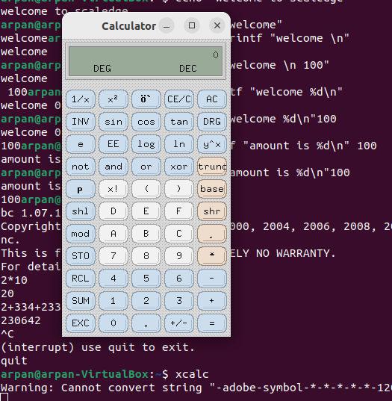

6)For writing a script :

Command: script

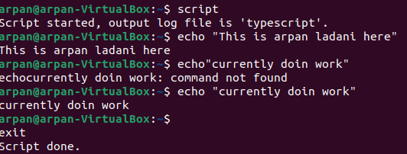

Similarly if we wanna se the script:

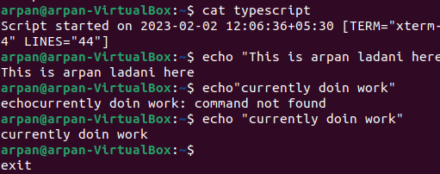Command: cat filename

7)To find who are using the system:

Command: who

8)To check the list of directory and files:

Command: ls-l

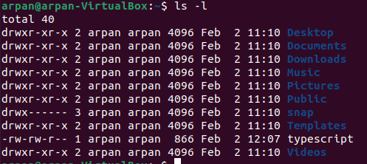

Here we can see that there is only one file i.e. typescript other all are directory as the first letter indicates.

3rd column tells us about the directory or file belongs to which person and respective group.

9)To change the permission of file:

Command: chmod (permission we want to give) filename

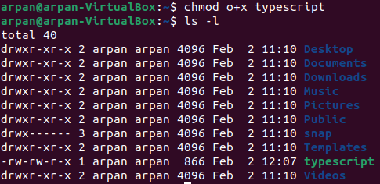

10)To change the ownership of file:

Command: chown vatsal:arpan typescript

11)For deleting file Command: rm

For copying and moving files Command: cp filename newfilename

mv filename newfilename

12)For concatenating the files:

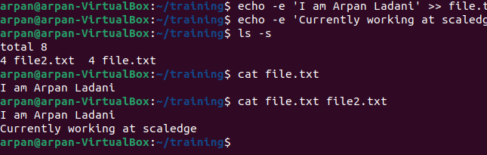Command: cat filename file2name

Also I have used echo -e for creating file with text.

13)Print file in reverse order in terminal:

Command: tac filename

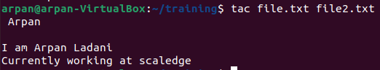

14)For seeing more and less in file respectively.

Command: more filename

less filename

15)For seeing statistics of file.

Command: wc filename



Here there are 3 lines,5 words and 26 characters in text file.

16)For comparing. Command: cmp file1name file2name.

For common. Command : comm file1name file2name

17)For compressing and decompressing the file respectively.

Command: gzip filename, gunzip filename

Similarly for recursively doing compression.

Command: gzip -r filename, gunzip -r filename

18) To create archive that contain multiples file or directory.

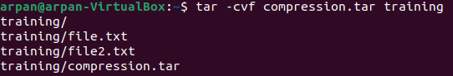

19)For displaying head and tail of a file.

Command: head -n [number of lines] filename,

tail -n [number of lines] filename.

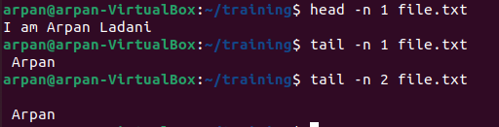

20)cut a column or a character specifically.

Command: cut -c [number by comma or range] filename.

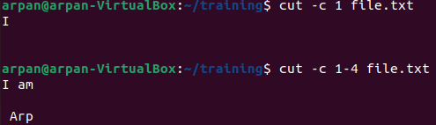

For cutting field we can use -f .

21)Sorting files in ASCII order.

Command: sort -t” “ -k [number by which u want to sort] filename.

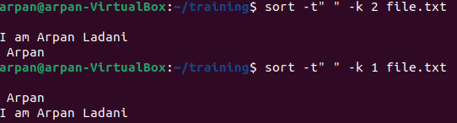

22)Grep scans for the pattern in the filename.